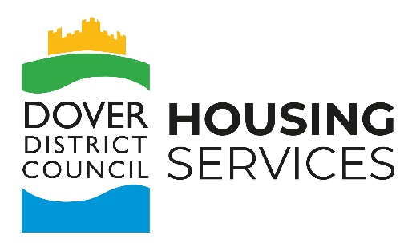

Bank Details Form
For Resident Expenses

Payment to be made to
Name:
Address Line 1:
Address Line 2:
Post Code:
Bank Details
Account Number:
Sort Code:
Declaration:  This information is accurate to the best of my knowledge and care has been taken in ensuring accuracy. |  | Signed:

Please note: Dover District Council is not responsible for inaccuracies in this form. We will pay to the account details provided so please take great care in ensuring it’s accuracy.

The information you provide is necessary and will only be used for the purpose of reimbursing expenses incurred as a result of getting involved in tenant engagement activities. The information you provide is stored securely and in accordance with data protection law. For further information on how the Council processes your personal data, and information you your data protection rights you can read our Corporate and Housing Services privacy notice at www.dover.gov.uk/privacy

Please provide your payment details each time you claim an expense.

