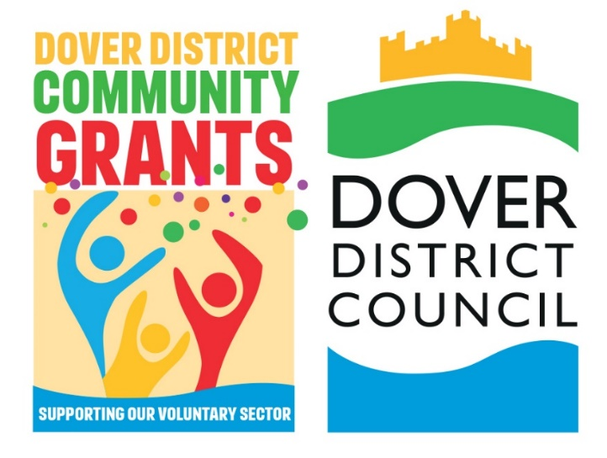

|  |
| --- |
| **Community Cohesion and Resilience Fund**  **2025**  **APPLICATION FORM** |

|  |
| --- |
| Before completing your application please ensure:   1. You use this form to complete your application. 2. You have reviewed the Information Pack. 3. Your application is submitted by 1pm on Wednesday 26th February.   If you have any questions about the Community Cohesion and Resilience Fund, please contact the officer below:  Contact Officer:  Name: Rebecca Dunroe (Community Development Officer)  Email: [CommunityGrants@dover.gov.uk](mailto:CommunityGrants@dover.gov.uk) |

| **Question** | **Response** |
| --- | --- |
| **Please confirm your *details*** | |
| Organisation/Group Name |  |
| Name of main contact |  |
| Position/Role |  |
| Contact Address |  |
| Telephone |  |
| Email address |  |
| **Please tell us about your project** | |
| What is the title of your project? |  |
| Where will your project take place? |  |
| Confirm your project will start and finish within 6 months? |  |
| Start Date |  |
| End date |  |
| Overview of your project? |  |
| *Your project must deliver against at least one of the following areas (Please tick all that apply)* | Bringing Communities Together |
| Raising Community Awareness & Support |
| *Your project must achieve outcomes in at least one of the themes listed (Please tick all that apply)* | Brings communities together to improve cohesion and reduce divisions in places facing the worst extremism challenges. |
| Improves the capability of places to tackle the extremist narratives and ideologies that are driving our communities apart. |
| Improves local partnership approaches to supporting community resilience by funding projects to strengthen ‘bridging’ social capital in at-risk places. |
| Improves the capability of places to respond to periods of community tensions through initiatives that strengthen community connections, promote unity and shared values. |
| How many beneficiaries will your project support? |  |
| How will you measure your project achievements? |  |
| Does your project require any permissions? (please attach any permissions to your email). |  |
| **Please tell us about your Management Committee** | |
| 1. Name, role and preferred contact number and email. |  |
| 1. Name, role and preferred contact number and email. |  |
| 1. Name, role and preferred contact number and email. |  |
| 1. Name, role and preferred contact number and email. |  |
| 1. Name, role and preferred contact number and email. |  |
| **Bank details** | |
| Name of Bank |  |
| Account Name |  |
| Account Number |  |
| Sort Code |  |
| Please confirm these details are correct. | Yes |
| **Please provide details of at least 2 signatories for this bank account** | |
| (Row 1) Signatories |  |
| (Row 2) Signatories |  |
| **Financial information** | |
| Does your group have any other Bank accounts in its name? |  |
| If so what |  |
| What is the annual turnover of your organisation/group? | £ |
| What are your current restricted reserves? (A description of this is available in our information pack). | £ |
| What are your current unrestricted reserves? (A description of this is available in our information pack). | £ |

|  |  |  |  |
| --- | --- | --- | --- |
| **Please tell us your full project costs** | | | |
| **Item** | **Cost** | **Funding source** | |
| Please describe this item | What is the full cost of this | Is DDC funding this cost | If not, who is and is the funding secured |
|  | £ |  |  |
|  | £ |  |  |
|  | £ |  |  |
|  | £ |  |  |
|  | £ |  |  |
|  | £ |  |  |
|  | £ |  |  |
|  | £ |  |  |
|  | £ |  |  |
|  | £ |  |  |

|  |  |
| --- | --- |
| *Please confirm your full project costs* | £ |
| Please confirm how much you are applying for, from the Community Cohesion and Resilience Fund. | £ |
| If you are applying for funding over £10k, please provide a brief response as to why. |  |
| Please provide information of any other funding streams that are funding any part of this project |  |

Thank you for completing this form.

To submit your application, please attach this form alongside a copy of a recent bank statement and constitution to:

**Contact Officer:**

Name: Rebecca Dunroe (Community Development Officer)

Email: [CommunityGrants@dover.gov.uk](mailto:CommunityGrants@dover.gov.uk)